Licencing of five varieties of different pulse crops (Moongbean, Urdbean, and Pigeonpea) with M/S Hi-Rich Seeds Co. Pvt. Ltd., Hyderabad, during the Industry-Stakeholders Conclave on 10th February 2025

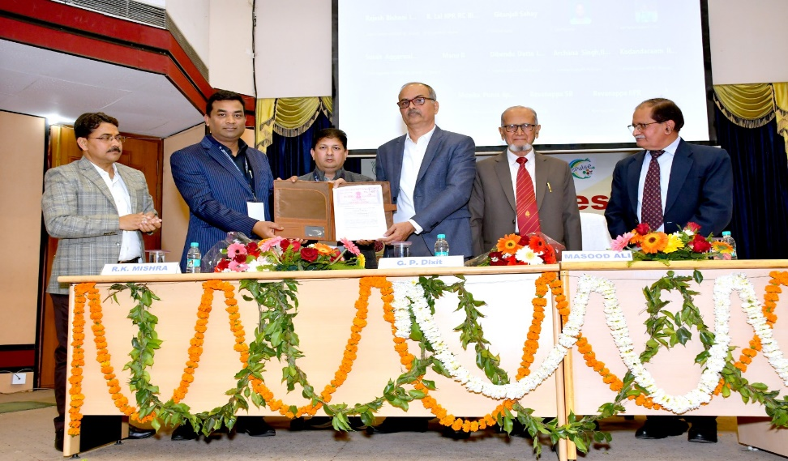

Licencing of Moongbean (Virat, Sikha) and Urdbean (IPU 13-1, IPU 11-2) varieties with M/S Sood Seeds Pvt. Ltd., Bazpur, Uttarakhand, during the Industry-Stakeholders Conclave on 10th February 2025

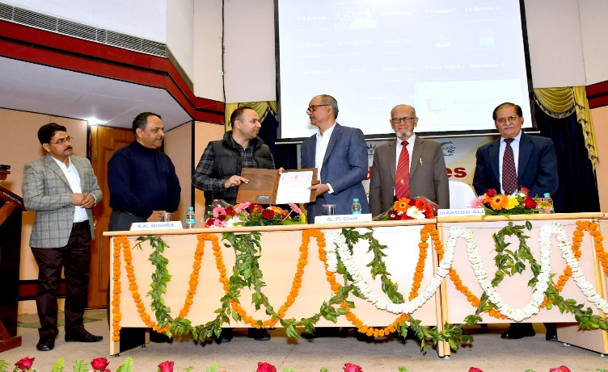

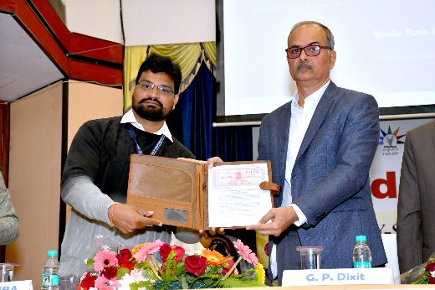

Licencing of Urdbean variety (IPU 17-2) with M/S Star Agri Sri Seeds Co., Sri Ganganagar, Rajasthan, during the Industry-Stakeholders Conclave on 10th February 2025