**Workshop on “Basics of Plant Molecular Biology and Genome Editing” held on**

**27 November, 2024**

**at IIPR, Kanpur**

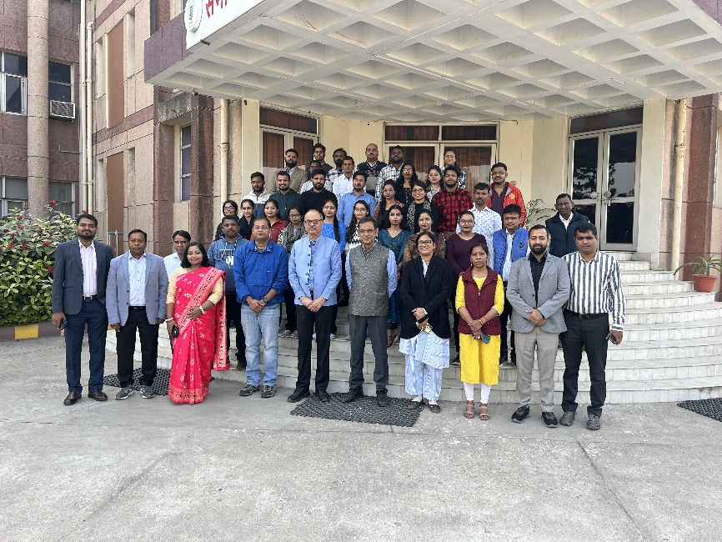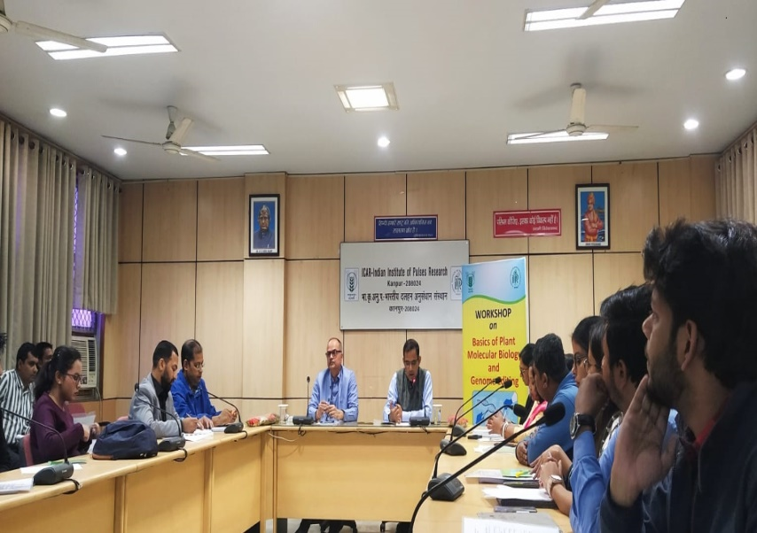

A Workshop on “Basics of Plant Molecular Biology and Genome Editing” was organized by the Division of Plant Biotechnology, IIPR, Kanpur, on 27 November, 2024 to sensitize project staffs and students on the basics and advances of Biotechnological tools and orient them toward the objectives of the Project. The Inaugural session was chaired by Dr G P Dixit, Director, IIPR and Dr Sujay Rakshit, Director, IIAB, Ranchi was Chief Guest on the occasion. Dr G P Dixit welcomed all participants and the Chief Guest and highlighted the importance of genome editing in pulses. He urged all to work in a focused manner to fulfil objectives of the Project. The Chief Guest, Dr Sujay Rakshit highlighted previous efforts by researchers and government to enhance pulses production and emphasized on the potential of genome editing to further improve pulses production and nutritional quality. He encouraged the participants to up skill themselves and urged on the necessity of planned and dedicated work for attaining desired results. Dr Alok Das, CC-PI, EFC Genome Editing Scheme, highlighted objectives of the Scheme wherein five research teams are working on different pulses (chickpea, pigeonpea, grasspea, urdbean and lentil) primarily to improve productivity and nutritional quality.

A total of eight interactive deliberations on topics including Basics of Genome Editing and Plant Molecular Biology, Principles of Tissue Culture, Direct (Particle Delivery System) and Indirect methods (*Agrobacterium tumefaciens/rhizogenes*) of gene transfer, Solution preparation and working protocols, Basics of Instrumentation and Good-laboratory practices were made. During the valedictory session, overview of the workshop was presented by Dr Meenal Rathore, Head of the Division wherein the need of more such workshops was shared. Feedback from participants was also shared. Director, IIPR appreciated the efforts made by the Division of Plant Biotechnology in sensitizing and capacity building of the research scholars and and emphasized the need to organize such workshops in future too. The workshop was convened by Dr. Antara Das and Mr. Sudhir K Jha.