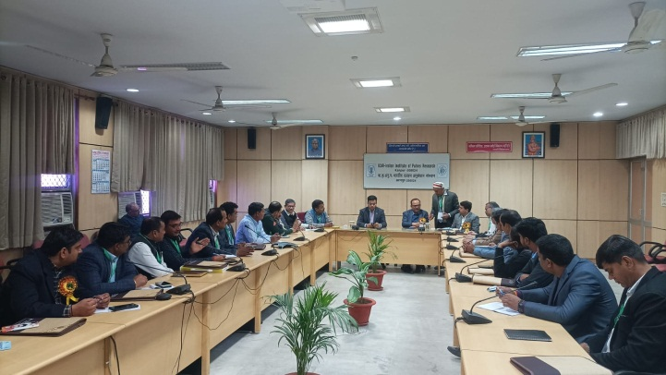
Institute Technology Management Unit (ITMU), ICAR-IIPR, Kanpur, is organizing two days of ‘Farmers-Scientists-Industry Stakeholders Meet-2024’ at ICAR-IIPR, Kanpur, on February 9–10, 2024. A total of 40 representatives from different industries across the country working in the area of pulse research and development, FPOs, and farmers participated. Mr. Raghavan Sampathkumar, Executive Director, Federation of Seed Industries in India, presided over the function under the chairman ship of Dr. G.P.Dixit, Director, ICAR-IIPR.
