Workshop Organized On Product Profile Development and Redefining Plant Types in Kharif Pulses

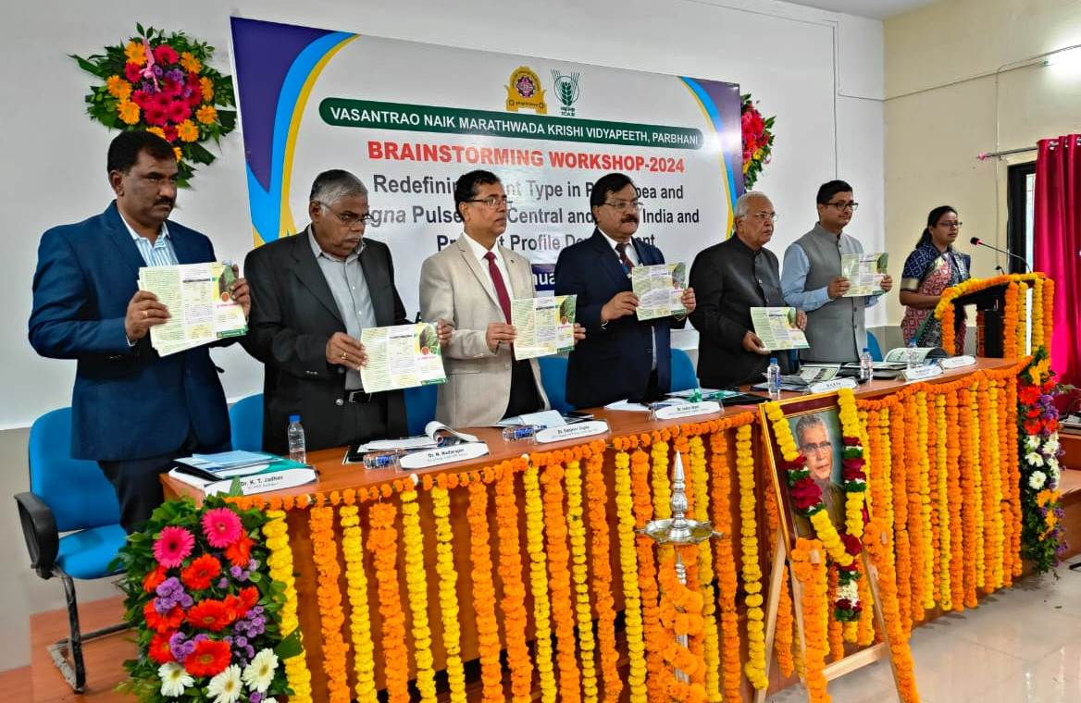

A brainstorming workshop on ‘Redefining plant type in pigeonpea and Vigna pulses for central and south India and product profile development’ was organized on January 8-9, 2024 at Agricultural Research Station, VNMKV, Badnapur, Dist. Jalna, Maharashtra. The workshop was organized jointly by AICRP on Kharif Pulses and ARS, Badnapur and >70 participants including
Dr. Indra Mani Mishra, Hon’ble Vice Chancellor, VNMKV, Parbhani, Dr. Sanjeev Gupta, ADG (O&P), ICAR, Shri Atul Kumar, Additional Chief Secretary, Govt. of Maharashtra, Dr. S.N. Puri, Former VC, CAU Imphal and MPKV, Rahuri, Prof. N. Nadarajan, Former Director, ICAR-IIPR, Kanpur and Dr. Aditya Pratap, Project Coordinator, AICRP on Kharif Pulses besides pulses scientists from central and south India, farmers, pulse Millers, seed sector and industries took part in the discussions. Elaborate deliberations were held on the need of redefining plant types in pigeonpea, mungbean and urdbean under the changing climate scenario as well as new productivity enhancement goals to meet the challenge of complete self-sufficiency in pulses by the end of 2027. In the debate that occurred, the panelists elaborated their ideas on the new traits that can be incorporated into new and desired plant structure of tur, mungbean and urdbean followed by an open house discussion wherein the participants aired their ideas about the most acceptable plant types. Each plant trait was discussed individually, based on which recommendations were made to shortlist the appropriate combination of traits in order to develop most productive and climate resilient plant types under different situations, for example, maturity durations in tur and seasons in mungbean and urdbean. A product profile development workshop was also organized during the event in which based upon the preference of researchers, consumers, millers and the market, a preliminary product profile was developed which will be further refined based upon inputs form more stakeholders. A ‘germplasm exposure day’ to showcase the rich diversity of genetic materials available at ARS, Badnapur and a ‘farmer-scientist interaction’ to understand the actual need of farmers to foster improved plant types were also organized on this occasion. This workshop has laid a foundation for organizing more such kindly of discussions in other pulses also and coming out with a productive and climate resilient plant type and a product profile to plan our future breeding programs. Dr. K.T. Jadhav, Scientist In-Charge, ARS, Badnapur was the organizing Secretary of this brainstorming meeting while Dr. D.K. Patil convened the program.

